Course: CS420 - Artificial Intelligence

03 – Constraint Satisfaction Problems

Question 1. You are designing a menu for a special event. The menu includes four dishes, each of which is a variable: (A)ppetizer, (B)everage, main (C)ourse, and (D)essert.
The domains of the variables are as follows:
A: (v)eggies, (e)scargot
B: (w)ater, (s)oda, (m)ilk
C: (f)ish, (b)eef, (p)asta
D: (a)pple pie, (i)ce cream, (ch)eese
Because all your guests get the same menu, it must obey the following dietary constraints:
(i) Vegetarian options: If you serve the veggies, you must avoid everything made of meat (red meat, poultry, seafood, etc.)
(ii) Dairy products lover: You must serve at least one of milk, ice cream, or cheese.
(iii) Digestible: The main course must be fish, or the beverage must be water or soda.

Formulate the problem as a CSP, stating the variables and corresponding domains.
Variables
Domains
Binary constraints:

Draw the constraint graph associated with your CSP, in which each node represents a variable and an edge connecting two nodes represents the relation between the two variables denoted by these nodes.

Again, imagine we first assign A=v. Cross out eliminated values to show the domains of the variables after arc consistency has been enforced.
Variables
Domains

Give a solution for this CSP or state that none exists.

Question 2. You are a map-coloring robot assigned to color the given map. Adjacent regions must be colored a different color (R=Red, B=Blue, G=Green).  - Draw the constraint graph | 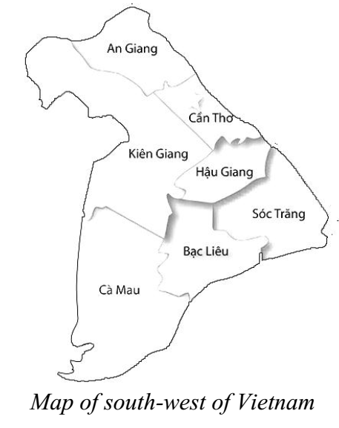
- Find a solution by using backtracking search with appropriate heuristics (MRV, DH, and LCV). Justify your answer.

